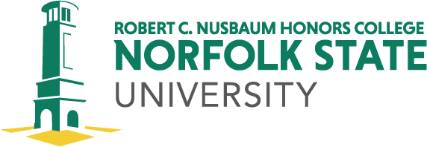

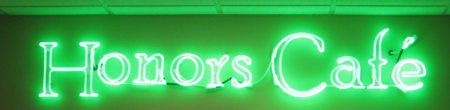

for FALL 2021
Virtual
Tuesdays from 4:30-5:30 p.m.

Dates
Sept. 7 Semester Launch-Dr. Khadijah O. Miller, Interim Dean RCNHC
14 RCNHC Student Summer 2021 Internship Presentations
21 FBI Internships-Career Services
28 Presentation By EVMS/CHKD : The Intriguing Case of the Yellow Baby: A case presentation and explanation
Oct. 5 Dr. April Manalang (Interdisciplinary Studies)-“A Climate of Hostility: Rise of Anti-Asian Hate in the Time of COVID”
12 Dr. Geoffroy de Laforcade (History & Interdisciplinary Studies)-“Cuban Roots/Bronx Stories” documentary film (by Pam Sporn)
19 Dr. de Laforcade “Cuba at a Crossroads: What are the Stakes through the Lens of Race”?
26 Dr. Uzzie Cannon (English and Foreign Languages) “Digital Humanities for Ethnic Studies”

Nov. 2 Dr. Felicia Mebane (Executive Director of Public Health Initiatives)-“Why Public Health Narratives Matter: The Importance and Power of Lifting Our Voices to Tell Our Stories”
9 Dr. Erica Russell (Psychology)
16 Mr. Torian Lee (Director of Global Learning and International Programs)
23 Thanksgiving Break
30 Dr. Michele Rozga (English and Foreign Languages)-“Visual Metaphors in Works of Native American Literature”
TBA RCNHC Graduating Seniors Recognition

Attendance strongly recommended for Honors College students. All events will be virtual in Zoom.

