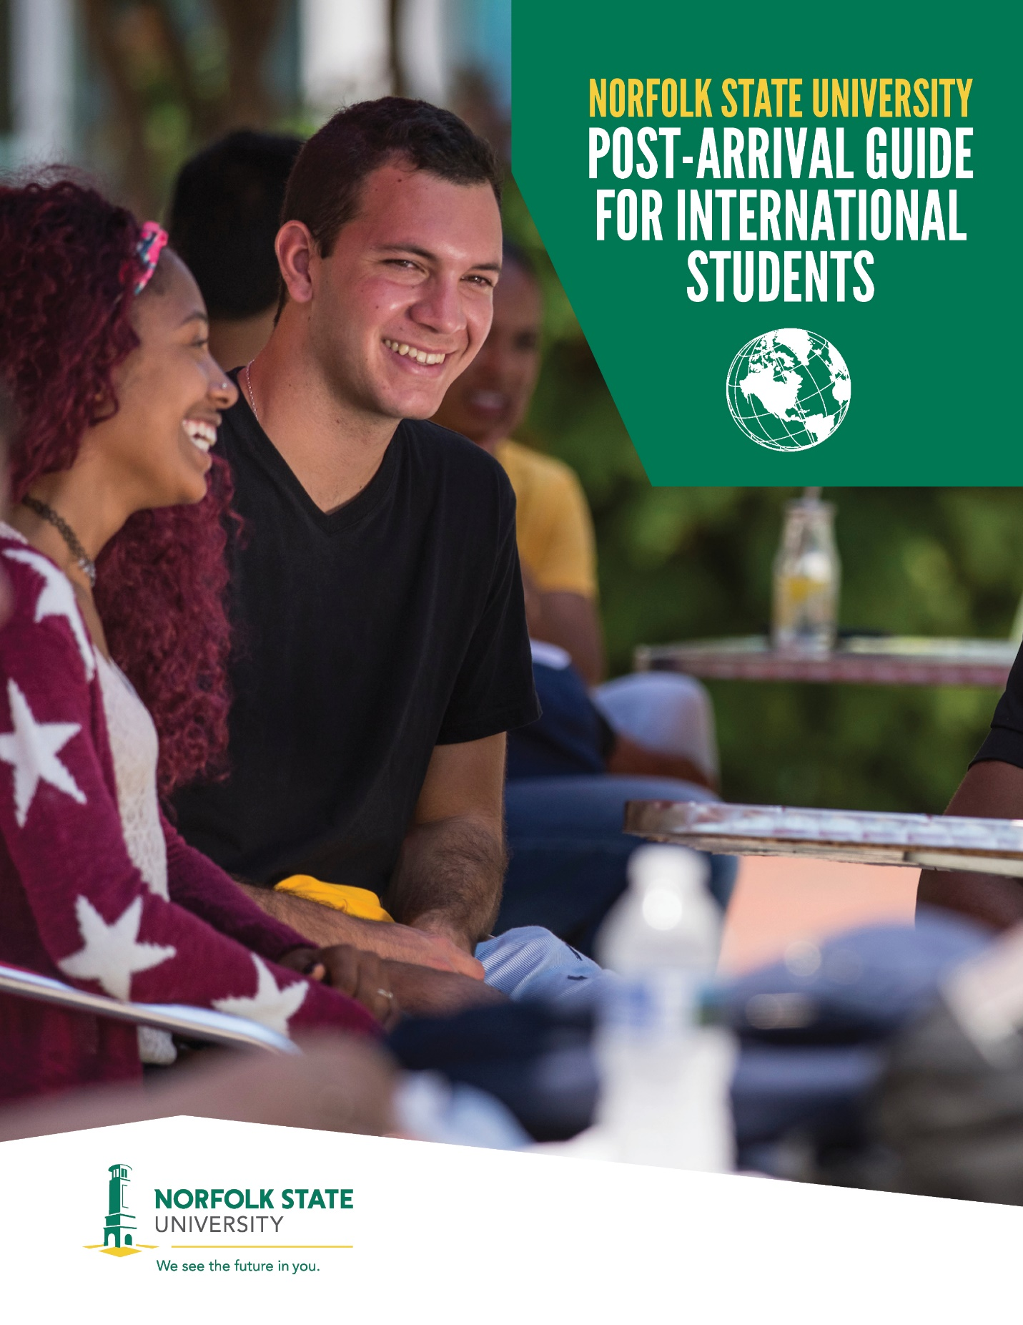

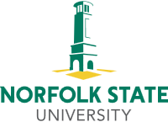

Welcome to Norfolk State University!

International Student Services (ISS) is pleased to welcome you to Norfolk State University (NSU). There are many services and programs available on our campus, which will allow you to make the most of your educational experience. ISS encourages you to take advantage of these opportunities so that you and the university community can both benefit from your presence here.

This guide has been designed specifically to help international students adjust to their arrival at NSU. It is hoped that the information contained herewith will provide a helpful introduction to the programs and services available at the university and help facilitate your transition to life in the United States.

As questions arise, please feel free to call or stop by the office located in the James A. Bowser Building, Suite 121. I will be more than glad to work with you should you need any assistance.

ISS and the NSU community hope you have a wonderful experience as an international student in the United States.

Sincerely,

Beverly B. Harris, Ed. D.

Director, International Student Services

Portions of this publication have been adapted with permission from Lock Haven University’s A Guide for International Students.

**TABLE OF CONTENTS**

**THE OFFICE OF INTERNATIONAL STUDENT SERVICES.......................................................................6**

**FIRST AND FOREMOST.............................................................................................................................7**

**Post-Arrival Checklist.................................................................................................................................7**

**Emergencies................................................................................................................................................7**

**IMMIGRATION INFORMATION...................................................................................................................8**

**How to Maintain Your Legal Status in the U.S. ...................................................................................8**

**Re-entering the U.S. After a Temporary Absence (5 months or less)................................................9**

**I-20 Endorsement…….............................................................................................................................9**

**Your Responsibility.................................................................................................................................9**

**EMPLOYMENT IN F-1 STATUS................................................................................................................10**

**On-Campus Employment…..................................................................................................................10**

**Off-Campus Employment......................................................................................................................10**

**Curricular Practical Training.................................................................................................................10**

**Optional Practical Training…….............................................................................................................11**

**Obtaining a Social Security Number..................................................................................................11**

**IMPORTANT DOCUMENTS......................................................................................................................12**

**Your Visa Documents..........................................................................................................................12**

**Social Security Card............................................................................................................................12**

**NSU ID Card (Spartan Card)................................................................................................................12**

**Virginia Driver’s License......................................................................................................................12**

**PERSONAL BUSINESS.............................................................................................................................13**

**Bank Accounts.....................................................................................................................................13**

**Your NSU Email Account.....................................................................................................................13**

**NSU Postal Services..............................................................................................................................13**

**FINANCIAL AID.........................................................................................................................................14**

**Sources of Financial Aid.....................................................................................................................14**

**Establishing Credit...............................................................................................................................14**

**ACADEMICS............................................................................................................................................15**

**Academic Advising and Registration...............................................................................................15**

**Grading System..................................................................................................................................15**

**Credit Hours..........................................................................................................................................16**

**Academic Honesty…………...............................................................................................................16**

**Classroom Participation....................................................................................................................16**

**Attendance….......................................................................................................................................16**

**CULTURE SHOCK.....................................................................................................................................17**

**What is Culture Shock? ......................................................................................................................17**

**Things You Can Do to Counter Culture Shock ................................................................................17**

**HOLIDAYS IN THE UNITED STATES.......................................................................................................18**

**HEALTH AND MEDICAL CARE................................................................................................................19**

**Mandatory Health Insurance...............................................................................................................19**

**Spartan Health Center..........................................................................................................................19**

**LEGAL MATTERS.....................................................................................................................................20**

**General Laws.......................................................................................................................................20**

**Rules about Drinking Alcohol............................................................................................................20**

**Consequences of Using False Identification....................................................................................20**

**Illegal Drug Use...................................................................................................................................21**

**Weapons...............................................................................................................................................21**

**Sexual Harassment..............................................................................................................................21**

**Smoking................................................................................................................................................22**

**Reporting Criminal Activity and Other Emergencies.........................................................................22**

**Taxation.................................................................................................................................................22**

**CAMPUS SAFETY.....................................................................................................................................23**

**Emergency Call Boxes........................................................................................................................23**

**Spartan Patrol......................................................................................................................................23**

**Safety Tips............................................................................................................................................23**

**STUDENT SERVICES................................................................................................................................24**

**Counseling Center................................................................................................................................24**

**Substance Abuse Services..................................................................................................................24**

**Parking Services...................................................................................................................................24**

**Student Success Center……………………………………………………………....................................25**

**Library...................................................................................................................................................25**

**LEISURE ACTIVITIES................................................................................................................................26**

**Office of Student Activities..................................................................................................................26**

**Campus Ministry...................................................................................................................................27**

**NSU Athletic Events.............................................................................................................................27**

**GETTING AROUND TOWN.......................................................................................................................27**

**About Norfolk, Virginia.........................................................................................................................27**

**Transportation…...................................................................................................................................27**

**LOCAL SERVICES....................................................................................................................................28**

**Bakeries………….................................................................................................................................28**

**Banks....................................................................................................................................................28**

**Beauty Salons and Barber Shops......................................................................................................28**

**Churches and Worship Centers.........................................................................................................28**

**Drugstores……....................................................................................................................................29**

**Grocery Shops......................................................................................................................................29**

**Hospitals and Clinics.............................................................................................................................29**

**Hotels.....................................................................................................................................................29**

**Movie Theaters....................................................................................................................................29**

**Pizza (Delivery)...................................................................................................................................30**

**Post Office..........................................................................................................................................30**

**Restaurants........................................................................................................................................30**

**SITES AND ACTIVITIES IN AND AROUND NORFOLK, VIRGINIA.........................................................31**

**RESOURCES.............................................................................................................................................31**

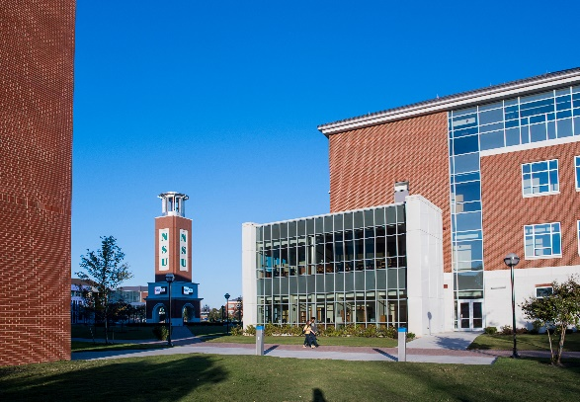

**THE OFFICE OF INTERNATIONAL STUDENT SERVICES**

The Office of International Student Services assists international students with matters related to immigration as well as to promote international education and intercultural understanding. The office circulates immigration information and acts as a referral source for students. Functions include issuing visa documents; advising students; processing immigration petitions; and serving as a liaison between the international student and the university government agencies.

**Services Include:**

* Issuing visa documents for first-time and transfer students
* Advising students on immigration matters
* Writing letters on behalf of students for visa purposes
* Providing assistance with cultural acclimation
* Assisting with obtaining basic needs and services like housing and banking
* Filing immigration petitions
* Filing authorizations for program extensions and reduction of course load
* Assisting with filing for reinstatement or obtaining renewals for visa documents
* Processing changes of address
* Assisting with practical training and employment
* Providing orientation sessions and workshops for students
* Providing academic support and referrals

**Contact**

International Student Services

James A. Bowser Building, Suite 121

Phone: (757) 823-8325

Fax: (757) 823-2640

Email: [InternationalStudentServices@nsu.edu](mailto:InternationalStudentServices@nsu.edu)

Hours of operation: Monday-Friday, 8 a.m. - 5 p.m.



**FIRST AND FOREMOST**

There are a number of things you must remember to do upon arrival. This period of time can be the most stressful. Below is a list of things you may want to remember to do once you have arrived in the United States in preparation for the start of the semester.

**Post-Arrival Checklist**

* Get settled in your apartment or residence hall. Purchase basic necessities, like an alarm clock, sheets, blankets, and toiletries.
* Get your phone/internet connected and phone home.
* Stop by International Student Services at James A. Bowser Building, Suite 121 to complete transfer and/or check-in; bring passport, visa, I-94 form and I-20 with you. Bring dependent’s I-94 form and I-20, too, if applicable.
* Open a bank account.
* Meet with your advisor during New Student Orientation or in his/her office if you have missed orientation. Register for classes.
* Have your student ID made at SpartanCard Office.
* Pay your tuition, fees, and room/board costs.
* Have money placed on SpartanCard (student ID).
* Buy books at the Campus Bookstore, located in the Student Center.
* Purchase a parking permit (if you own a car).
* Take a tour of campus and locate your classes.
* Obtain your social security card (if working on campus).
* Apply for a driver’s license or state identification card through the Virginia Department of Motor Vehicles (if necessary).
* Activate your NSU email account and Spartan Shield.
* Attend New Student Orientation Session for international students (mandatory) and school social events. Join student organizations.

**Emergencies**

**Immigration-Related Emergencies**

If you face difficulties at your consulate or at the port-of-entry and need immediate assistance, please call 757-823-8325.

If the matter occurs after business hours, call the University Police Department at 757-823-8102. Identify yourself as an international student, explain the nature of your emergency, and ask that Dr. Beverly Harris is called.

**Personal Emergencies**

If you face a non-immigration-related emergency such as an accident or crime, call the University Police Department’s emergency number at 757-823-9000. If the matter is extremely urgent or occurs off-campus, dial “911”.

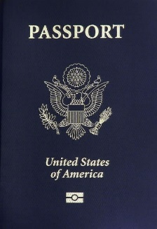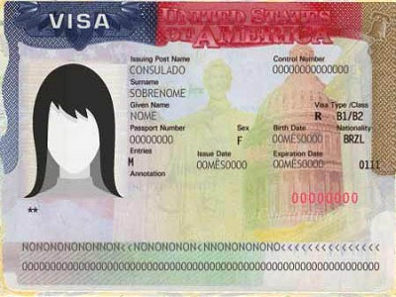

**IMMIGRATION INFORMATION**

**How to Maintain Your Legal Status in the United States**

The consequences for failing to maintain legal status in the U.S. are becoming increasingly more severe. It is relatively easy to stay in status if you observe the following rules:

* Take a full course load each semester (12 credit hours - undergraduates; 9 credit hours -graduates). If you meet the criteria for a reduced course load, obtain a clearance from the Designated School Official (DSO) prior to the end of late registration.
* Do not withdraw from classes without consulting the DSO.
* Do not let your I-20 expire. If you need more time to complete your studies, apply for an extension at least 30 days before your form expires. The expiration date is printed on line 5 of the I-20 or line 3 on the DS-2019.
* Maintain a passport valid for six months into the future.
* If you need to leave NSU for a short-term or take a permanent leave of absence (except vacations), notify the DSO and/or submit a Program Departure Form. The Program Departure Form is available on the website and allows the DSO to update your information in SEVIS and the school database. If you fail to complete this form, your SEVIS record will be terminated and you will not be allowed to return to the United States.
* If you change your visa status or file for permanent residency, notify the DSO.
* If there are any changes in the information on your I-20/DS-2019, notify the DSO so that your I-20 can be updated.
* Examples of situations when a new form is needed: change in sponsor or financial information, change of major, change of name, change of citizenship, etc.
* Plan ahead and submit requests to the DSO in advance of when you will need them.
* Make certain that you maintain health insurance coverage for yourself and your dependents living in the U.S.
* Never work off-campus in the U.S. without prior approval from the United States Citizenship and Immigration Services (USCIS.) You must not accept employment even if the employer or your academic advisor states that it is allowable.
* Never work on-campus more than 20 hours per week when classes are in session.
* Request a re-entry signature from the DSO prior to traveling abroad.
* Keep track of your visa expiration date and make certain to apply for a new one on your next trip home if necessary, so that you are able to return to the United States.
* Report any changes in your address in the U.S. or in your home country to the DSO within 10 days. This is done by submitting a Change of Address Form, available online.
* Notify the DSO of any dependents in F-2 or J-2 status who will accompany you in the U.S. The DSO must obtain biographical information as well as receive notification as to the time they arrive and/or depart.
* Complete proper transfer procedures if you change schools. You must submit a Separation Form and Transfer Out Form to the DSO, obtain a new I-20 or DS-2019, and report to the new school within 15 days of the program start date.

**How to Maintain Your Legal Status in the United States (continued)**

• Notify the DSO before enrolling in an online course. You may not apply more than 3 credit hours toward the full-time minimum.

• Notify the DSO before enrolling at another institution while attending Norfolk State University.

**Re-entering the U.S. after a Temporary Absence (5 months or less)**

To re-enter the U.S., you must have the following documents:

• Valid passport

• Valid visa

• Current I-20 with a valid signature

• A copy of your transcript

• Verification of enrollment letter

**I-20 Endorsement**

It is crucial that you have a valid signature from ISS on page 2 of your I-20 in order to re-enter the United States. Students who do not have a valid signature on their I-20 are not able to reenter the country. The signature is valid for one academic year.

**It Is Your Responsibility to Maintain Legal U.S. Status**

Understanding the relevant immigration regulations and maintaining your legal status as an international student in the U.S. *is your responsibility*. Be proactive. Plan your course schedules carefully so that you maintain full-time status. Make travel arrangements early and anticipate delays at consulates or ports of entry. Keep all your documents up to date, and give time for processing new forms.

Stay informed. Do not rely on your friends or the media for accurate information regarding immigration issues. As well-meaning as friends may be, they may not be aware of new developments and practices.

Please do not hesitate to stop by International Student Services (James A. Bowser Building, Suite 121), or call 823-8325 if you have any questions or concerns.

**\*Please note that the office can only assist you and cannot provide legal advice.**

**Visit the following websites for more information:**

U.S. Citizenship and Immigration Services (USCIS): <https://www.uscis.gov/>

National Association for Foreign Student Advisors (NAFSA): <http://www.nafsa.org>

Norfolk State University: <http://www.nsu.edu/Campus-Life/Services-Resources/Disability-Services/International-Student-Services>



**EMPLOYMENT IN F-1 STATUS**

**On-Campus Employment**

F-1 students, unfortunately, do not qualify for federal financial aid. Many of the jobs on campus are “work-study” jobs, which are positions paid by federal funds as part of a student’s financial aid package. F-1 students are not eligible for “work-study”. F-1 students CAN apply for and obtain employment with departments contracted through the University or non-work-study positions. Some places to seek on-campus employment include the University Bookstore, Student Success Center, Food Services, Athletics Department, Office of Residential Life/Housing, University Police Department, your academic department, and the NSU website (Human Resources).

International students, in general, may work on campus only, and for no more than 20 hours per week during periods when class is in session. Students may work more than 20 hours per week during holidays and breaks. No formal authorization from the United States Citizenship and Immigration Services is needed prior to beginning employment. If your employer has questions about your employment eligibility or about how to complete the Form I-9, ask him/her to please contact the Office of International Student Services.

International students must obtain a Social Security Card from the Social Security Administration to receive compensation for their work. See section below for instructions on how to apply for a Social Security number.

**Off-Campus Employment**

As an F-1 visa student, you may not work off-campus without authorization from the United States Citizenship and Immigration Services. There are only a few reasons the USCIS will grant a non-immigrant student permission to work outside of campus including severe economic hardship based on an unforeseeable change in one’s financial situation and practical training. For more information about these employment categories, visit the NSU website.

Please be mindful that F-1 students may not work more than 20 hours per week while school is in session. They may work more than 20 hours during breaks and holidays.

**Curricular Practical Training**

Off-campus work authorization may be granted by the DSO to an F-1 student in the form of Curricular Practical Training (CPT). The training must be an integral part of the established curriculum (such as a co-op or internship), in the student’s field of study. This means that the employment must meet one of these two criteria: practical experience is required for graduation, or practical training yields course credit.

CPT may be approved for part-time (20 hours or less) or full-time (over 20 hours). The student must have an offer of employment from an employer offering work that qualifies as curricular practical training prior to applying for CPT. Use of 12 months or more of full-time CPT eliminates eligibility for Optional Practical Training (OPT).

For application forms and instructions, please contact ISS.

**Optional Practical Training**

F-1 students are entitled to up to 12 months (cumulative) of Optional Practical Training (in the official term), or "OPT", intended to give the student a chance to apply his/her education to the workplace and gain practical experience by allowing for a limited period of employment directly related to the student’s curriculum.

Post-completion practical training is available after one has completed the formal course of study. The student must be enrolled full-time for a minimum of nine consecutive months prior to application. A student may apply for pre-completion practical training, as well, but it is generally limited to 20 hours per week while school is in session.

Pre- and post-completion practical training require specific authorization from the USCIS (U.S.Citizenship and Immigration Service). Approximately 3 months before course completion, the student should file an application for an EAD (Employment Authorization Document). You may no longer apply after the completion of studies.

For application forms and instructions, please visit the ISS.

**Please note the following:**

1. Any time spent in pre-completion optional practical training is deducted from the 12-month allowable period. Part-time pre-completion OPT is deducted from the 12-month limit at 50%. Mandatory curricular practical training is not deducted.
2. Pre-completion OPT is limited to 20 hours per week when the student has coursework to complete. Over 20 hours per week can be requested for pre-completion OPT done during official school breaks or after the student has completed all coursework required for the degree while the student is completing a thesis or dissertation.
3. Employment must be related to field of study.
4. Prior use of full-time Curricular Practical Training for one year or more eliminates eligibility for Optional Practical Training.
5. Although no offer of employment is required prior to application, the student is expected to work or to be actively seeking employment after the EAD card is issued.
6. Authorization for post-completion practical experience is granted for 12 months only and must be completed within 14 months of the last day of classes or exams. Twelve months of post-completion practical training is allowable after each level of study (for example **-**12 months after bachelor’s degree and another 12 months after completion of master’s degree.)

**Obtaining a Social Security Number**

To secure a Social Security Card, you must first obtain an offer of employment. Student jobs on campus are limited. If you are planning on obtaining a job on campus, you should follow these steps:

1. Visit various departments (bookstore, police department, cafeteria, etc.) and ask about job opportunities before classes begin.
2. After you have a job offer, visit ISS for a letter to be completed by the employer verifying

employment.

1. Take the letter along with your passport, I-94 form and I-20 form to the Social Security Administration to apply for a Social Security Card. The nearest office is located at 5852 Lakeview Road off of North Military Highway in Norfolk.
2. The official card will be mailed to you in 2-3 weeks.



**IMPORTANT DOCUMENTS**

**Your Visa Documents**

It is important that you safeguard your passport, visa, I-94 form, and I-20 form. Carelessness is the main cause for losing these documents or having them stolen. If your passport is lost or stolen, you should report the loss immediately to the local police and to the nearest embassy or consulate of your home country. If you can provide the consular office with the information contained in your passport, it will facilitate issuance of a new one. Therefore, it is a good idea to make two photocopies of the data page of your passport. Keep one copy separately from your passport in your room, and leave the other copy with a relative or friend. There is a fee charged by the United States Citizenship and Immigration Services for this service. If your I-20 is lost or stolen, visit ISS for a new copy.

**Social Security Card**

A Social Security Number (SSN) is required in order to work in the United States. A SSN is also helpful to do a variety of things such as opening a bank account, obtaining health insurance, etc.; however, you may not obtain a SSN unless you have an offer of employment. You will need to obtain a SSN before you begin work at NSU and to receive your paycheck. The SSN is given to you in the form of a card, which you will have to sign. After receiving your card from the Social Security Administration, memorize your number and keep it in a safe place. Never give your SSN to anyone. Please refer to page 11 for more information about how to obtain a social security number.

**NSU ID Card (SpartanCard)**

Every NSU student, including international students, must obtain an NSU identification card (ID card). You may obtain your ID card at the SpartanCard Office located in the Student Services Center, Room 109. The NSU ID card is provided by the university to all students, staff, and faculty members. The card is used as identification. It is also used to access meal plans and flex dollars, to purchase text books, and to borrow books from the university library. Moreover, it is used for free admission to most cultural, social, and sporting events on campus.

**Virginia Driver’s License**

In order to apply for a Virginia Driver’s License, you must appear in person at a Virginia Department of Motor Vehicles (DMV). The State of Virginia requires the following documentation from non-U.S. citizens applying for a Virginia driver’s license or a learner’s permit: your unexpired passport; your visa; your unexpired I-94 form; your unexpired I-20; proof of Virginia residency in the form of a bank statement, official transcript, utility bill, etc.; and your Social Security Number. For a list of other acceptable documents, please visit ISS or visit the DMV website at [www.dmvnow.com](http://www.dmvnow.com).

Bring these documents to ISS. We will fax them to the DMV “Identification Review Services,” which will review the documents and issue a letter acknowledging your eligibility for a driver’s license. Take the letter with your original visa documents and proof of Virginia residency to the DMV to apply for your license or ID card.

The nearest DMV is located at 850 Widgeon Road. Take Tidewater Drive North for approximately 4 miles. Widgeon Road will be on your right.

**PERSONAL BUSINESS**

**Bank Accounts**

To secure your money, ISS suggests that you open a bank account. Never store money or valuables in your room; and never carry more than $100 cash on your person. It is not a difficult task to open either a savings or a checking account, and you should not need a Social Security Number. If you encounter difficulty opening a bank account without a Social Security Number, please visit ISS for guidance. It is often helpful to take a letter from ISS to the bank to assist you and the teller with this task.

Upon opening a checking account, you will receive an ATM card. ATM stands for Automated Teller Machine. This card will allow you to withdraw out of or deposit money into your account 24 hours a day at any ATM location. There are several ATM machines on campus that are affiliated with the Bank of America. Almost all ATMs have bank names. If you use one that is affiliated with a bank that is different from your own, you will usually be charged a fee (usually $2-$3). If you work on campus, ask about “Direct Deposit”, which allows your compensation to be automatically deposited into your checking account. This is a very convenient way to keep your money safe in the bank and at the same time available to you immediately.

**Your NSU Email Account**

Email accounts are automatically issued when a student registers at NSU. **It is very important that you log in and check your NSU email regularly**! Offices such as the Office of the Registrar, Student Financial Services, and International Student Services will send selected official communications to students via email. Emails might include individualized or group messages such as Financial Aid award letters, Residential Life room assignments, advising appointments, or immigration information.

The University will use **only** your NSU account to communicate with you. If you fail to check your NSU email account on a regular basis, you may miss very important emails. It is the student’s responsibility to promptly report any problems with email accounts or access to email to the Office of Information Technology Help Desk at 823-8678.

**NSU Postal Services**

Mailboxes are assigned individually to on-campus residents with a valid student identification card. The ID is necessary to retrieve mail and packages. Residents should not allow others to retrieve their mail. They should use only the name specified on their NSU ID for incoming mail. All delivered packages must be picked up immediately upon notice of delivery. The University encourages packages to be delivered by UPS. Students receiving packages by UPS must have their building name and room number indicated on the package.

The University Mail Room is located on the first floor of the Student Services Center. Hours of Operation: Monday-Friday, 8 a.m.–5 p.m. for daily pick up. Phone: (757) 823-8332. **The University mailroom is closed on weekends.**

Full mail service is provided at the U.S. Post Office located at the corner of Church Street & Brambleton Avenue.



**FINANCIAL AID**

**Sources of Financial Aid**

There is limited financial assistance for students, outside of federal financial aid for which international students do not qualify. Scholarships are available through various departments at NSU. Visit the NSU website under “Financial Aid” for a copy of the Scholarship Guide, which provides a list of all available NSU scholarships, deadlines, and application information.

Outside scholarships can be found on the NSU website and through other sites such as Fastweb (www.fastweb.monster.com) or International Education Financial Aid ([www.iefa.org](http://www.iefa.org)). You can also contact your embassy or consulate to see if there are government funds available from your home country to assist you.

Some other methods to obtain additional funding include on-campus employment, private loans, and credit cards. Becoming a resident assistant (RA) or graduate assistant (GA) within the residence halls provides the student free room and board. If you have a U.S. co-signer, you can obtain a loan through banks and organizations such as Campus Door (www.campusdoor.com), or Citibank ([www.studentloan.com](http://www.studentloan.com)). If you have a good history of credit within the U.S., you may qualify for a loan through Access Group (www1.accessgroup.org).

**Establishing Credit**

Establishing credit is sometimes difficult for international students. Try to apply for a credit card through several different companies, like Citibank and American Express. Some companies will start students off with a very small credit card limit or will require a deposit. To establish good credit, you must be sure to make your credit card payments on time. It is best to pay off the balance every month.

Often, it helps to have on-campus employment prior to applying for a credit card. Not only will you have documented income, you will also have a Social Security Number, which is sometimes a requirement. If you are employed on campus, you should qualify for a credit card through the Virginia Credit Union ([www.vacu.org](http://www.vacu.org)), which offers lower interest rates than traditional companies.



**ACADEMICS**

**Academic Advising and Registration**

All students who enroll at Norfolk State University are assigned an academic advisor, usually during New Student Orientation. Your advisor will assist you with course selection, academic progress, career planning, and registration for classes. Work closely with your academic advisor so that you can be certain you are enrolled in appropriate classes. If you are unsure about the faculty member to whom you are assigned, visit your department’s main office.

You may also add and/or drop classes by accessing your student account online at “Spartan Shield”; however, you must first obtain a clearance through your academic advisor. Please keep in mind that there are limited seats for each course. This means that there is a possibility that you will not be able to register for all of your desired courses. To find out what courses and sections are still open, please visit the website, click on “Spartan Shield” and enter your log-in information.

**Grading System**

American colleges and universities use a variety of different grading systems, the most common of which is the numeric system. In this system, a student's grades are averaged, yielding a grade point average (GPA). At NSU, grades are assigned by professors based upon criteria that are usually specified in the course syllabus, provided at the beginning of the class. The percentages provided below represent an approximation of the grading system utilized by most professors to assign grades. You should use this chart only as a guide, as different professors may use different criteria.

Grades Numeric Values Percentages (%)

A 4.0 97.5 - 100.00

A- 3.7 92.5 - 97.4

B+ 3.3 90.0 - 92.4

B 3.0 87.5 - 89.9

B- 2.7 80.0 - 82.4

C+ 2.3 77.5 - 79.9

C 2.0 72.5 - 77.4

C- 1.7 70.0 - 72.4

D+ 1.3 67.5 - 69.9

D 1.0 60.0 - 67.4

F 0.0 0.0

*P None Pass

**AU None Audit

I None Incomplete

W None Official Withdrawal

* Pass/fail grades are not available to graduate students, except in those courses designated for pass/fail credit.

** Entered by the registrar

**Credit Hours**

A credit hour is a unit of measure representing the equivalent of an hour (or 50 minutes) of instruction per week over the entire term. Therefore, a three credit class would yield 3 hours of instruction per week. It is generally recommended that a student spend 2 hours of outside study for each credit hour taken. Hence, a full course load of 12 credit hours would require 24 additional hours of study per week outside the classroom.

**Academic Honesty**

NSU expects all students to be academically honest. Professors insist that their students fulfill course requirements in an ethical manner. Plagiarism is a very serious offense and punishment could be as harsh as expulsion. If a professor assigns you to do a research paper, you are to work on it alone and are not allowed to copy sources without giving credit to them. Also, you must complete examinations without taking or giving assistance. What you may think of as 'helping' may be considered cheating and could result in a failing grade or worse. If you have any questions about what constitutes cheating or plagiarism, please ask your professor.

**Classroom Participation**

Many international students come from educational systems where speaking to the professor during or after class may not be acceptable. This is not the case at most American universities, including NSU. In the U.S., there exists a great deal of interaction between teachers and their students. In fact, almost all professors encourage students to join in class discussions and express their opinions. Many instructors include class participation in determining a student's grade and will lower the grade if the student does not ask questions or make comments in class. All instructors at NSU have office hours, a regular time when they are available in their offices to meet with students. These are posted on their office doors. You should take advantage of these times to visit your professors even if you are doing well in their courses.

**Attendance**

The University expects students to attend all classes; however, we understand that on occasion, students may have legitimate reasons for being absent. Thus, a student will be permitted one “unexcused” absence per semester hour credit or the number of times a class meets per week. Once a student exceeds the number of allowed unexcused absences, an instructor may require an official University excuse. No more than 20% of class meetings (excused or unexcused) may be missed by a student during a given semester. At the discretion of the instructor, a student whose absences exceed 20% of class meetings for the semester may receive a grade of “F” for the course.

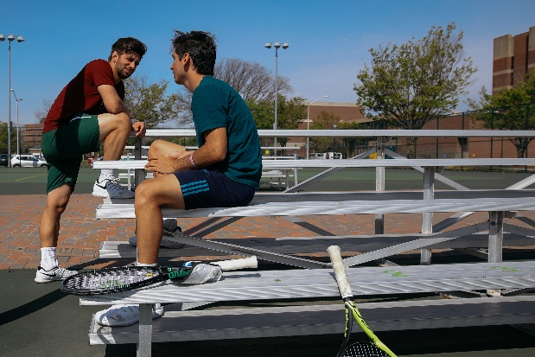

**CULTURE SHOCK**

**What is Culture Shock?**

"Culture Shock" is a phrase used to describe the psychological effect of being immersed in a new culture. The U.S. culture is made up of other cultures mainly brought by immigrants. Americans have many values, traditions and foods. Initially, being in a different environment will excite you; but, as time goes by, you may become depressed, have trouble sleeping (or want to sleep too much), have trouble concentrating, eat poorly, think that no one understands how you feel, begin to alienate yourself from others, and want very badly to go home.

Culture Shock occurs as a result of being displaced from home. It is a reaction of sadness about missing the things that are familiar to you, like food, sights, smells, landscapes, and family/friends. It is also an adjustment to new rules, habits, and people. For example, in some countries, neighbors are considered as “family” and are often relied upon to take care of residents in the neighborhood. One student stated that she missed this part of her culture, and that here in the United States; she has not even spoken with her neighbors. “I feel isolated,” she stated. Other students related their experiences with difficulties in developing new friendships.

To cope effectively with culture shock, you should realize that you are not alone. Every international student experiences the same types of feelings upon arrival in the United States. Americans who travel abroad go through a period of culture shock, too.

**Things You Can Do to Counter Culture Shock:**

1. **Get involved and meet people.** Perhaps the most important thing you can do is to meet others so that you can learn about and experience American culture. Join an organization, find fellowship in the residence hall or participate in religious services.

1. **Talk about it.** Discuss your feelings with persons who may be going through the same thing. Remember, this may be the first time away from home for some American students, too, and they may be feeling homesick, too.
2. **Connect with persons from your home country.** If you are unable to locate any, visit the Office of International Student Services. We may be able to assist you in finding a group of persons on campus or outside the University from your home country.
3. **Phone home!** When you find yourself homesick, call or write family and friends at home.
4. **Visit ISS to talk about your feelings.** If you experience severe homesickness or culture shock, we may refer you to speak with a professional counselor in the University Counseling Center, which offers personal counseling to students free of charge.

**HOLIDAYS IN THE UNITED STATES**

**New Year's Day (January 1st):** Large parties are held on New Year's Eve (December 31st), when people gather to cheer in New Year's Day. January 1, is often a day for family reunions, and for many people, a day of watching football games and parades on television.

**Valentine’s Day (February 14th):** It is a holiday that celebrates love. On this day, boyfriends, girlfriends and friends exchange Valentine’s Day cards and gifts. Common gifts include flowers, chocolate, and jewelry.

**Easter Sunday (1st Sunday after the 1st full moon after March 21st):** A very important Christian holy day commemorating the Resurrection of Jesus Christ. Religious services are conducted during the week proceeding Easter and on Easter Sunday.

**Memorial Day (Last Monday in May):** This day commemorates deceased family members and those who died at war. People often place flowers on graves.

**Independence Day (July 4th):** National holiday celebrated with patriotic parades, picnics and many community activities, including fireworks.

**Labor Day (1st Monday in September):** Holiday honoring all laborers. Events have a flavor of "last chance for summer."

**Halloween (October 31st):** Also known as the Day of the Dead, Halloween is a fun festival, especially for children, who wear costumes and go from house-to-house for candy. Many carve pumpkins and have fun activities, such as costume parties and storytelling about monsters, witches, and ghosts.

**Thanksgiving (4th Thursday in November):** Fall festival commemorating the first successful harvest for the immigrants to this continent. A traditional feast, featuring roast turkey, celebrates this day.

**Christmas Day (December 25th):** A very important holy day celebrating the birth of Jesus Christ. The Christmas season, which begins after Thanksgiving Day and runs

until December 25, includes traditions such as the exchange of cards and gifts among friends and relatives. Children believe in "Santa Claus", a jolly bearded man who lives at the North Pole and delivers toys to all good children on the night before Christmas. During the holiday season, people decorate their homes with Christmas trees and colored lights.



**HEALTH AND MEDICAL CARE**

**Mandatory Health Insurance**

In the United States, health care is very expensive. Since there is no national healthcare system in the U.S., it is extremely important that you have adequate health insurance. There is nothing worse than receiving huge medical bills when you do not have insurance.

At Norfolk State University, it is mandatory for every international and exchange student to have health insurance. Therefore, every international student will automatically be enrolled in the university’s health plan, which includes sickness, accident, and prescription drug benefits. Students who carry another type must be approved by the University’s Insurance Representative. Forms must be completed every year. For more information about health insurance, please stop by ISS.

**Spartan Health Center**

Basic health services provided under the student health program include diagnosis and treatment of minor illnesses and injuries; provision of selected over-the-counter medication and medical supplies; supervised care in designated observation beds; general and emergency medical services; health education counseling; maintenance of immunization/health history records; forums and materials on preventive health, mental health, and other health-related areas; and injections of allergy serum (at students’ expense). The Center is staffed with highly skilled health care professionals specializing in medicine, surgery, family practice, gynecology, and emergency care.

The costs for the health care services listed above are paid by the University for students who are enrolled full-time. Costs incurred for care that exceed the services listed above must be paid by the student or by his or her private health insurance. Furthermore, the Health Center can refer students to local physicians and hospitals, as well as those physicians who are a part of the NSU health insurance network.

The Spartan Health Center is located within Spartan Station. Hours of operation are 8 a.m.-5 p.m., Monday through Friday, with walk-in hours from 8 a.m.-10 a.m.



**LEGAL MATTERS**

**General Laws**

International students and visitors in the United States must obey the same laws as Americans. If you break the law, you will be treated the same as an American. If you are found guilty of a crime in the U.S., you may be deported and may lose your right to return to the United States.

These are some things that can get you in serious trouble or have you arrested:

• Fighting in public or other acts of violence;

• Possession of a weapon;

• Possession of an open alcohol container in public;

• Underage drinking;

• DUI (Driving Under the Influence of any incapacitating substance); and

• Urinating in public

**Rules about Drinking Alcohol**

It is illegal for anyone under the age of 21 to buy and/or drink alcohol. It is also illegal to be drunk in public and to drive after drinking. If you drive under the influence, you may be sent to jail, have to pay a very expensive fine, lose your driver’s license, and even lose your car. It is also against the law to have an open container of alcohol in the streets or in your car, meaning the driver can be arrested if a passenger is drinking alcohol in the vehicle.

NSU is a “dry campus”, which means that consumption of alcohol on campus is prohibited even if you are over 21 years of age. Some other violations include possession of alcohol; carrying an open container in public; hosting a party involving the illegal use of alcohol; dispensing and/or facilitating the dispensing of alcohol to minors; and intoxication. For more information about sanctions for alcohol violations, please see Student Disciplinary Policies and Procedures in the NSU Student Handbook, downloadable from the NSU website.

**Illegal alcohol possession and use off-campus is a Class 1 misdemeanor with much stiffer penalties, including loss of driver's license, fines up to $2,500 and a maximum sentence of up to one year in jail.**

**Consequences of Using False Identification**

It is illegal for anyone to intentionally use, make or sell an identification card falsely representing one’s identity, gender, age, etc. According to Virginia law, young adults (ages 18-20) who use an altered or fake ID such as a driver's license, birth certificate or student ID to buy, possess or drink alcohol can lose their driver's license for up to a year, be fined up to $2,500 and face up to 12 months in jail.

**Falsifying immigration documents (passport, visa, etc.) is a more serious offense prosecuted by federal authorities, which may result in a prison term and/or deportation.**

**Illegal Drug Use**

Use and/or possession of marijuana, narcotics, illicit drugs, or drug paraphernalia (except as expressly permitted by law or University regulations) on property owned or controlled by the University is strictly prohibited.

The sale or distribution of marijuana, narcotics, or dangerous drugs (except as expressly permitted by law) on property owned or controlled by the University or at functions sponsored or supervised by the University is strictly prohibited. Persons found to be involved in the sale of illegal drugs will be subject to expulsion from the University.

**The sale or illegal use of drugs off-campus can yield much stiffer penalties, including a fine, prison sentence, and/or deportation.**

**Weapons**

Norfolk State University has a zero tolerance policy for weapons and violence.

Weapons include but are not limited to the following: knives, razors, broken bottles, brass knuckles, chains, locks, all guns, firecrackers, or any other objects used to threaten or cause injury to/upon another.

Violence includes but is not limited to: uncontrollable physical or verbal abuse and/or gang-related activities toward any student, faculty, staff, administrator, or visitor on property owned or controlled by Norfolk State University. Behavior of this type may result in **immediate expulsion** from the University.

**Possession of a weapon off-campus can yield much stiffer penalties, including a fine, prison sentence, and/or deportation.**

**Sexual Harassment**

Sexual harassment includes unwelcome sexual advances, requests for sexual favors, or physical or verbal behavior of a sexual nature which has the effect or intent of intervene individual’s academic or work performance by creating an intimidating, hostile or offensive environment.

Based on your own cultural experiences, you may believe that sexual harassment is not a possible occurrence, or that it won’t happen to you. In some cultures, for example, sexual harassment between a faculty member and a student could never occur because, unlike in the U.S., informal relationships between faculty and students are forbidden.

Some cultures may assume that a woman appearing in public alone is announcing her availability for sexual activity. Or, it may be assumed that relationships between men and women are primarily romantic or sexual. In the United States, however, women frequently appear alone in public with the expectation that they will be treated in a nonsexual manner, and men and women typically interact on a nonsexual basis as colleagues and friends.

Sexual harassment is not only a violation of Norfolk State University policy, it is also a violation of state and federal law. While different cultures may permit varied behaviors between and among the sexes, certain behavior that may be interpreted as harassment will not be tolerated at this institution.

**Violators may be subject to University disciplinary action and/or arrest.**

**Smoking**

Smoking is defined as the carrying or holding of any lighted pipe, cigar or cigarette of any kind or any other lighted smoking equipment, or the lighting, inhaling or exhaling of smoke from a pipe, cigar or cigarette of any kind.

Smoking is not permitted within facilities owned or leased by the University, in university-owned vehicles or buses, or at loading docks or any other location where work is being conducted outside.

Smoking is prohibited inside the buildings and smoking outside must occur at least 15 feet clear of any building entrance, air intake duct, window, or other pathway or exit where others would be subjected to passive smoke. Smoking outside the buildings and vehicles must be done only in areas where there is an ash container in which to deposit the ashes and other smoking remnants.

**Reporting Criminal Activity and Other Emergencies**

It is the Norfolk State University Police Department’s policy to protect the rights, the safety and the welfare of the students, faculty, staff, and members of the community. Every person on campus has the right to be free from threats or acts of violence. Everyone is expected, as well as required, to comply with all state, local and federal laws.

Any person living, studying, working and/or visiting the University campus who is victimized or has knowledge of a criminal action/offense or other emergency should immediately contact the Norfolk State University Police Department or any “Campus Security Authority” (a University official who has significant responsibility for student and campus activities). Students, faculty, staff and visitors are also encouraged to report all suspicious persons or activities witnessed on campus and in the surrounding communities.

Incidents may be reported in person or by dialing the non-emergency number (**823-8102).** In emergency situations, dial the emergency number (**823-9000**). The Norfolk State University Police Headquarters is located in the University Police Department Building (near Scott/Dozier Dining Hall and the Residential Housing Complex). Police officers and police sergeants are in constant communication with the University’s telecommunications center, and are on duty 24 hours a day, 365 days a year. Officers are dispatched immediately after a call is received.

All calls, complaints, and serious incidents will be investigated by the University Police Department. Violations of the law can result in referrals to the Student Services/Judicial Affairs or charges by the Norfolk State University Police Department and/or local police.

** Taxation**

All international students are responsible for compliance with U.S. laws and regulations, and may be obligated to pay U.S. income taxes. Students should refer to Internal Revenue Service (IRS) publications to determine their tax status and filing requirements. Publications, tax forms, and instructions are available via the IRS website at <http://www.irs.gov/formspubs/index.html> or by calling 1.800.829.3676. Forms are also available at libraries and post offices.

Faculty and staff at Norfolk State University are not permitted to give individual tax advice. Students with complicated tax situations may wish to consult with a tax preparation service, professional tax accountant, or tax attorney who is knowledgeable about nonresident tax law, or you can use downloadable tax software such as the one offered by Glacier Tax Prep (GTP): [www.glaciertax.com](http://www.glaciertax.com)

[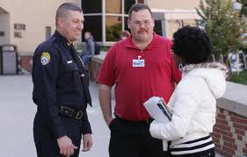](http://www.google.com/imgres?q=campus+safety+act&start=85&hl=en&sa=X&qscrl=1&nord=1&rlz=1T4ADBS_enUS327US404&biw=1280&bih=760&tbm=isch&prmd=imvns&tbnid=oXD-NEqkavd-FM:&imgrefurl=http://policecrunch.com/2011/06/29/campus-safety-ii/&docid=VbIjaZggI17MpM&imgurl=http://policecrunch.com/wp-content/uploads/2011/06/Campus-Police1.jpg&w=610&h=389&ei=eiqsT8ODGuTX0QHR5uz6Dw&zoom=1&iact=hc&vpx=495&vpy=2&dur=8563&hovh=179&hovw=281&tx=210&ty=123&sig=107730385876580425419&page=4&tbnh=133&tbnw=190&ndsp=30&ved=1t:429,r:26,s:85,i:61)

**CAMPUS SAFETY**

**Emergency Call Boxes**

“Blue light” emergency call boxes are located throughout the campus. This security measure is provided to ensure safety. Simply pushing the large black button activates the call box and connects the individual to the campus police dispatcher. The dispatcher will then identify the activated call box by number and ask for the nature of the emergency (e.g., “call box number 3, what is your emergency?”) Persons should try to remain calm and speak loudly and clearly while giving the location and nature of the emergency.

**Spartan Patrol**

Campus escorts are provided by the NSU Police Department to walk students across campus after dark. The service is available from 5 p.m.-9 p.m. Call NSU police at 757-823-8102 to request an escort.

**Safety Tips**

There are several things you can do to protect yourself and your belongings. Using your common sense and trusting your instincts are first and foremost in self-protection.

• Do not walk alone.

• Always be aware of your surroundings. Stand straight, walk with your head up, swing your arms.

• Do not accept transportation from a stranger.

• Take the elevator instead of the stairs, but never get on an elevator if there is someone already on it with whom you do not feel comfortable.

• Carry a cell phone and pepper spray.

• Lock your doors and look to see who is at the door before you open it.

• Keep your valuables locked and in a safe place and do not carry large amounts of cash.

• Use your common sense--do not put yourself in compromising positions. Do not drink or use illegal drugs.

• Always let someone know where you are going before leaving your home or residence hall.

• Keep car doors locked. Install a car alarm if possible.

• When approaching your car in a parking lot, check beneath it and in the back seat before you enter.

• Always park in a well-lit area.

**NSU ALERT SYSTEM**

**Emergency Alert Program**

Get alerted about emergencies and other important community news by signing up for our Emergency Alert Program. This system enables us to provide you with critical information quickly in a variety of situations, such as severe weather, unexpected road closures, and evacuations of buildings or neighborhoods. You will receive time-sensitive messages wherever you specify, such as your home, mobile or business phones, email address, text messages and more. You pick where, you pick how. To sign up for emergency alerts, contact Regina Lightfoot at [rllightfoot@nsu.edu](mailto:rllightfoot@nsu.edu). If you already have an account log on below.

* [Login to Everbridge](https://member.everbridge.net/index/1332612387831954#/login)

**USE THE LIVESAFE APP**

**The free app allows for easy communication with NSU police.**

**Here’s how you can get the app:**

1. Open Google Play or the Apple App Store on your phone. Search for "LiveSafe" and download the option with the blue shield.
2. Tap "Sign up." Fill in your profile information and create a password.
3. Norfolk State University may pop-up if you are close to the campus. If so, tap "Yes." Otherwise tap "Change" to select Norfolk State University.
4. Remember, safety and security is everyone’s business.

* [About LiveSafe](https://www.livesafemobile.com/solutions/)



**STUDENT SERVICES**

**Counseling Center**

The Counseling Center provides a range of counseling services for Norfolk State University students at no charge. Services include individual and group counseling, crisis intervention, and educational outreach programming. Counselors are also available to consult with students, parents and staff about issues that affect student life. Adjustment difficulties, depression, troubled relationships, and the inability to manage stress are some reasons that students seek counseling services. During a crisis, counselors are dispatched to provide emergency intervention and support for affected community members. Crisis counseling is available to students 24 hours a day.

The Counseling Center staff includes counselors and professional therapists as well as graduate students working under close supervision. All counselors are trained and experienced in addressing issues common among university students. Appointments can be made by phone or in person. Individuals seeking counseling are assured confidentiality. For further information, please visit the Counseling Center in Room 312, Student Services Center, or call (757) 823-8173.

**Substance Abuse Services**

The Counseling Center offers substance abuse support and services. The staff is trained to respond effectively to students personally affected by alcohol or drug use. Substance abuse education and prevention programs, including National Alcohol Screening Day, are also administered by the Counseling Center.

**Parking Services**

Students who wish to park on campus must register their vehicles with Parking Services. Shuttle bus services, operated by Parking Services, are also available free of charge for the campus community. Shuttle stops are located across campus, and buses run every 10-15 minutes.

Decal fees, parking passes and all parking inquiries should be directed to the Office of Parking Services at 823-2211. The office is located on the 1st floor in the Police Building.

**Dr. Patricia Lynch Stith Student Success Center (PLSSSC)**

The PLSSSC academic advisement services focus on providing information to help students achieve educational goals and establish intentional partnerships that lead to academic success. Professional Advisors provide information and resources that help (primarily) freshmen and sophomore students. Programs offered by the success center are peer mentoring, tutoring services, and the Spartans Preparing for Academic Rigor in College Summer Bridge Program (SPARC).

For more information about **The Student Success Center** contact the **office** at **(757) 823-8507, email ssc@nsu.edu or visit the website at** [**www.nsu.edu**](http://www.nsu.edu)

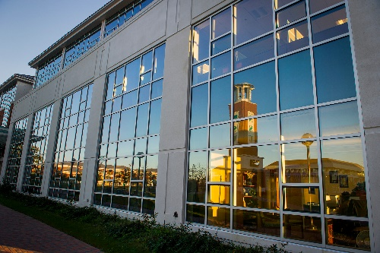

**Library**

The Lyman Beecher Brooks Library is located on the main campus of NSU. The circulation desk, located on the first floor of the library, is staffed with faculty librarians to assist students, faculty, and staff with both print and electronic information retrieval. The first floor of the library houses a general computer lab open to Norfolk State University students.

Hours of operation are: Monday-Thursday: 8 a.m.-11 p.m.

Friday: 8 a.m.-5 p.m.

Saturday: 9 a.m.-5 p.m.

Sunday: 2 p.m.-10 p.m.

***Holiday and summer hours will be posted at the entrance of the library.***

***Library hours are subject to change.***



**LEISURE ACTIVITIES**

**Office of Student Activities & Leadership**

The Office of Student Activities & Leadership is responsible for the coordination and implementation of a creative, responsive, and diverse co-curricular program at Norfolk State University. Norfolk State University strives to cultivate individuals who have not only mastered academic coursework, but have also developed active interests and skills in interpersonal relations. Student Activities provides quality recreational programs and services that enhance the academic, recreational and leisure experiences of NSU students, such as dance parties, ice and roller skating, laser tag, and movies. The Office is located on the third floor of the Student Center.

**The Student Center**

This facility is the heart of student activity, where organizations hold formal meetings, students gather to play cards, billiards, or table tennis, and planned events are often held. Programs encourage a healthy, balanced lifestyle and the constructive, socially acceptable use of leisure time.

**Intramurals**

Intramural sports offer students and staff the opportunity to participate in various structured individual and team activities that range from recreational to competitive. These activities are designed to meet the creative interest of the diverse university community and to help students and staff improve both fitness levels and social skills. The skills acquired in the intramural program will encourage future sports participation and healthy habits that will last a lifetime. The following sports are available: softball, tennis, basketball, flag football, ping pong, dodge ball, billiards, and golf. For more information on how you can get involved, please contact Vicki Collier at [vmcollier@nsu.edu](mailto:vmcollier@nsu.edu) or call 757-823-8200.

[](http://www.google.com/imgres?q=campus+ministry&hl=en&sa=X&qscrl=1&nord=1&rlz=1T4ADBS_enUS327US404&biw=1280&bih=760&tbm=isch&prmd=imvns&tbnid=IPxQJc8mUxrt5M:&imgrefurl=http://www.villa.edu/campus_ministry.html&docid=LePHHOUTSGZGiM&imgurl=http://www.villa.edu/cmsimages/CM_Headers-0-Main.png&w=690&h=180&ei=Rx6tT_i-Csjs0gHlr8T8Cw&zoom=1&iact=hc&vpx=412&vpy=417&dur=1469&hovh=114&hovw=440&tx=221&ty=69&sig=107730385876580425419&page=2&tbnh=45&tbnw=171&start=15&ndsp=30&ved=1t:429,r:2,s:15,i:127)**Campus Ministry**

The Wesley-Westminster Campus Ministry invites students of all religious backgrounds and denominations to participate in recreational programming and worship. The Campus Ministry is located at 2412 Corprew Avenue and can be reached at 757-823-8200. Other on-campus Christian organizations include the Baptist Student Union (757-823-8200), Catholic Campus Ministry (757-823-8200) and the Gospel Choir (757-823-8200).

Information about other denominations and places of worship can be found on page 28 of this manual.

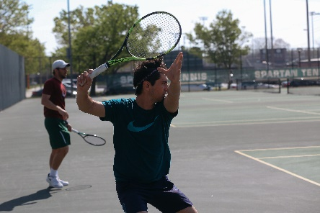

**NSU Athletic Events**

The Department of Athletics is comprised of the following varsity sports: men’s baseball and football; men and women’s basketball, cross-country, track and field, indoor track, and tennis; and women’s volleyball, softball, and bowling. The Department is a member of the National Collegiate Athletic Association (NCAA) and the Mid-Eastern Athletic Conference (MEAC).

Your NSU ID card gives you free admission to most athletic events on campus. You can find up-to-date information on all NSU teams, competition results and upcoming games, including times and places by visiting the NSU website.

**About Norfolk, Virginia**

Norfolk, Virginia, home to the largest naval station in the world, is a city rich in culture, recreation, and history. Granby Street is full of trendy restaurants and unique boutiques. You can dine or attend an outdoor festival at the Waterside Festival Marketplace and Town Pointe Park, which are less than 2 miles from campus. Or, if you are in the mood to shop, the upscale MacArthur Center Mall is just a few minutes from NSU. In Downtown, you can browse through museums or enjoy a ballet. Sports enthusiasts can enjoy a baseball game in Harbor Park, and animal lovers can see exotic animals at the Virginia Zoological Park.

Norfolk State University’s campus is just 20 minutes away from the resort city of Virginia Beach where you can relax on the beach, see a concert, dine, or enjoy the Virginia Marine Science Museum. Colonial Williamsburg, a historical landmark, is only a 45-minute drive from campus. In addition to history, Williamsburg is also home to Busch Gardens, one of the best area theme parks.

**Transportation**

The transportation system in the United States is quite different from many other countries. Most Americans own cars, which are the most common form of transportation.

Local public transportation in Norfolk is limited; however, you can get by without a car in town by taking the **Hampton Roads Transit System (HRT)**. The busses run continuously throughout the Hampton Roads area at a reasonable rate. The Tide, Virginia’s first light rail system, opened for service in Norfolk on August 19, 2011.  It extends 7.4 miles from the Eastern Virginia Medical Center complex east through downtown Norfolk and adjacent to I-264 to Newtown Road.  Eleven stations provide access to dining, shopping and entertainment as well as the Norfolk State University and Tidewater Community College (Norfolk) campuses.  There are four park-and-ride lots where parking is always free. For schedules and bus routes, visit <http://gohrt.com/>

For downtown travel, HRT offers the **Norfolk Electric Transit**, or NET. The weekday route is designed to accommodate the needs of commuters by connecting the park-and-ride lots with the major employment sites downtown. The weekend route has the visitor in mind, providing service to the major attractions in the downtown area. This service is free.

Norfolk State University also offers free transportation for students. The **campus shuttle** runs continuously across campus and to Old Dominion University. On weekends, the shuttle operates to transport students to and from Wal-Mart, MacArthur Center Mall, and Janaf Shopping Center. For shuttle stops and schedules, please contact Janet Jones with Facilities Management at 757-823-8947.

**Taxi cabs** are also available for transportation. Some Norfolk-based companies include Yellow Cab of Norfolk (857-8888), Norfolk Checker Taxi (855-3333), and Black and White Cabs (855-4444).

For distant travel, a **Greyhound Bus** Terminal is conveniently located in the center of town at 701 Monticello Avenue, on the corner of Monticello and Brambleton Avenues.

Another option is traveling by train. There is an **Amtrak** station located near the Norfolk State campus at 280 Park Ave, Norfolk, VA 23510, close to Harbor Park. Amtrak offers student memberships, which can get you not only great savings with fares but can also save you some money on food, clothes, etc. To learn how to obtain a student membership and find out about fares call Amtrak at 1-800-872-7245 or visit [www.amtrak.com](http://www.amtrak.com).

You can also fly to almost anywhere in the United States and abroad from Norfolk International Airport. For more information on flights, connections, arrivals, and departures, please visit www.norfolkairport.com. You may want to check airline websites to look for airfare deals. Many airlines in the U.S. offer special airfares to students.

**LOCAL SERVICES**

**Bakeries**

Naa’s Bakery 3527 Tidewater Drive 757-623-3858

**Banks**

Bank of America 1916 Colonial Ave. 757-664-1677

Wells Fargo 2000 Colonial Ave. 757-314-1700

**Beauty Salons and Barber Shops**

The Barber Shop and Co. MacArthur Center Mall 757-626-1192

Regis Salon MacArthur Center Mall 757-625-4445

**Churches and Worship Centers**

Baptist Churches

Gethsemane Comm. Fellowship 1317 E. Brambleton Ave. 757-622-0760

First Calvary Baptist Church 813 Henry Street 757-622-7418

Catholic Churches

St. Mary’s St. Paul’s Blvd. 757-622-4487

Christ the King 1803 Columbia Avenue 757-622-1120

Methodist Churches

Wesley-Westminster 2412 Corprew Avenue 757-533-9578

Epworth United Methodist 124 W. Freemason Street 757-622-2970

Mosques

Islamic Center 1442 W. 49th Street 757-423-8609

Masjid William Salaam 614 W. 35th Street 757-626-0734

Presbyterian Churches

First Presbyterian Church 820 Colonial Avenue 757-625-1697

Second Presbyterian Church 7305 Hampton Blvd. 757-423-2822

Orthodox Churches

Dormition Orthodox Church 1065 E. Bayview Blvd. 757-587-6369

Greek Orthodox-Annunciation 7220 Granby Street 757-440-0500

Temples & Synagogues

Conservative: Temple Israel 7255 Granby Street 757-489-4550

Orthodox: Chabad Lubavitch 1920 Colley Avenue 757-616-0770

Reform: Beth Chaverim 3820 Stoneshore Rd., VB 757-463-3226

Temples-Buddhist

Chua Giac Hoa 2019 Coira Street, Ches. 757-494-0278

**Drugstores**

Eckerd Drugs 770 W. 21st 757-627-5588

Rite-Aid 3600 Tidewater Drive 757-623-2706

Walgreens 810 W. 21st Street 757-623-7213

**Grocery Shops**

General

Food Lion 3530 Tidewater Drive 757-623-1469

Asian

Asian Grocery 5444 Virginia Beach Blvd. 757-456-0220

Caribbean/African

MP International Grocery 5957 E Virginia Beach Blvd 757-466-0220

Indian

Swagat’s Indian Spices & Specialties 309 Aragona Blvd., VB 757-499-7317

Latin

La Esquina Bodega 9610 1st View Street 757-248-2857

Mediterranean

Azar’s Natural Foods 2000 Colley Avenue 757-664-7955

**Hospitals and Clinics**

Bayview NowCare 7924 Chesapeake Blvd 757-587-1700

Little Creek Medical Associates 1326 E Little Creek Road 757-583-6338

Spartan Health Center Spartan Station 757-623-3090

Sentra Norfolk General Hospital 600 Gresham Drive 757-668-3000

**Hotels**

Hampton Inn Norfolk Airport 1450 North Military Highway 757-466-7474

Norfolk Downtown Radisson 700 Monticello Avenue 757-627-5555

Sheraton Norfolk Waterside 777 Waterside Drive 757-622-6664

**Movie Theaters**

Regal Cinemas MacArthur Center Mall 757-623-7500

Naro Expanded 1507 Colley Avenue 757-625-6276

The Commodore 421 High Street, Portsmouth 757-393-6962

**Pizza (Delivery)**

Chanello’s 901 W. 21st 757-628-8000

Domino’s 1120 Bainbridge Blvd. 757-494-7050

Pizza Hut Princess Anne 757-857-6666

**Post Office**

600 Church Street (Corner of Church St. and Brambleton) 757-629-9472

**Restaurants and Pubs**

Applebee’s (American) 5750 E. Virginia Beach Blvd. 757-461-6766

Lone Star Steak House (American) 450 N. Military Highway

Ruby Tuesday (American) 1201 N. Military Highway 757-461-5116

MP’s (Caribbean) 6109 E. Virginia Beach Blvd. 757-466-0220

Golden City (Chinese) 1002 Park Avenue 757-629-0888

Kin’s Wok (Chinese) 222 W. 21st Street 757-623-2933

The German Pantry (German) 5329 Virginia Beach Blvd. 757-461-5100

Dawat (Indian) 888 N. Military Highway 757-455-8080

Rajput (Indian) 742 W. 21st Street 625-INDIA (4634)

Fellini’s (Italian) 3910 Colley Avenue 757-625-3000

Kotobuki (Japanese) 721 W 21st Street 757-628-1025

El Rodeo (Mexican) 5834 E. Virginia Beach Blvd. 757-466-9077

*Please note that this list is not meant to be all inclusive, nor does the University endorse any of the listings. Locations were chosen randomly from those closest to the University.

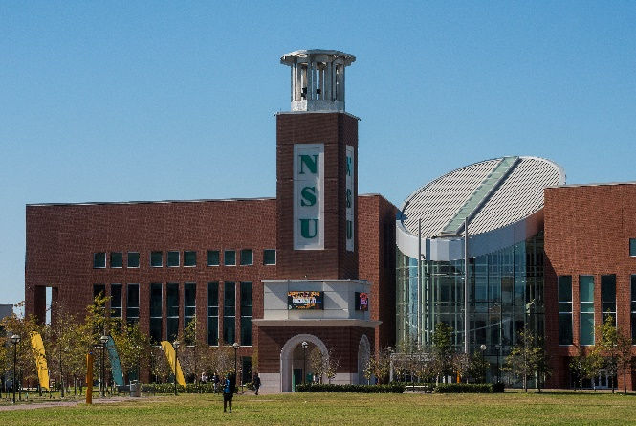

**SITES AND ACTIVITIES IN AND AROUND NORFOLK, VIRGINIA**

**Waterside** - A gallery of eateries. Waterside Drive, Downtown Norfolk

**The Norva** - A small concert venue; 317 Monticello Avenue, Downtown Norfolk

**Towne Pointe Park** - Home to summer festivals; Waterside Drive, Norfolk

**MacArthur Center Mall** - Large upscale shopping mall; 300 Monticello Avenue, Downtown Norfolk

**Nauticus** - Nautical museum. Waterside Drive, Downtown Norfolk

**Botanical Gardens**- Beautiful gardens for nature lovers. 6700 Azalea Garden Road, Norfolk

**Harbor Park**- Baseball stadium. 150 Park Avenue, Downtown Norfolk

**Virginia Zoo** - Renovated and updated zoological park. 3500 Granby Street, Norfolk

**Virginia Beach Oceanfront -** Beautiful beaches. Virginia Beach

**Ocean Breeze Park**- Water Park; 849 General Booth Blvd., Virginia Beach

**The Virginia Beach Amphitheatre** - A Large concert venue; 3350 Cellar Door Way, Virginia Beach

**Virginia Marine Science Museum** - Aquatic Museum; 717 General Booth Blvd., Virginia Beach

**Colonial Williamsburg/ Jamestown -** Historic Sites; Williamsburg, Virginia

**Busch Gardens/Water Country** - Amusement Parks; Williamsburg, Virginia

**RESOURCES**

Norfolk’s Visitor Guide

<https://www.norfolk.gov/index.aspx?NID=9>

Virginia Visitor’s Guide

<http://www.virginia.org>

Life in the USA: A complete Guide for Immigrants and Americans

<http://www.lifeintheusa.com/>

