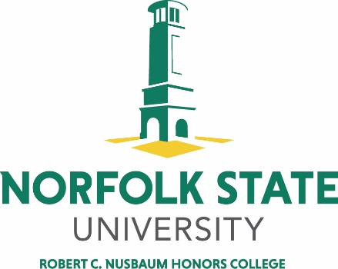
NORFOLK STATE UNIVERSITY
Scholarship Program
The Robert C. Nusbaum Honors College Scholarship

Criteria: This scholarship is for incoming full-time freshmen or incoming full-time transfers with an associate’s degree and demonstrable financial need. Students must have a 3.0 GPA or above for both categories and at least a 1080 combined SAT (Math + Verbal) or 21 ACT for entering freshmen only. Students are required to complete 30 credit hours of Honors courses at NSU including the designated capstone, or 18 H hours if a student transfers in with an associate’s degree.
Amount of award: $4,000 per year for 4 years.
Student must meet all Honors College standards.
This scholarship is supported by a grant to the Hampton Roads Community Foundation by Ms. Mary Clark Janis to honor her friend Mr. Robert C. Nusbaum, a valued, long-time patron of the NSU Honors College.
APPLICATION

Name_________________________________________________________________________
(Last) (Middle) (First)

NSU Student ID ________________________________________________________________

Telephone (Home and Cell, if different) _____________________________________________

Street Address__________________________________________________________________

City/State/Zip _________________________________________________________________

NSU Email (if assigned; otherwise use personal email) _________________________________

Last School Attended____________________________________________________________

School Address ________________________________________________________________

Date of Entry to NSU ___________________________________________________________

Major ________________________________________________________________________

Signature _____________________________________________________________________

Date _________________________________________________________________________

(Your signature indicates your approval for the Screening Committee to gather information relevant to your application.) In addition to this form, the following are required to complete the application package:

- A statement of at least 500-1,000 words giving your current understanding of the goal of honors education on the college/university level. Please carefully cite your use of any secondary sources.

(2) Two letters of recommendation written on your behalf.

All application materials should be forwarded to:

ROBERT C. NUSBAUM HONORS COLLEGE
700 PARK AVENUE
GWC BROWN MEMORIAL HALL SUITE 236
NORFOLK, VA 23504

QUESTIONS? Call (757) 823-8208.

Applications may also be hand-delivered.

This form may be copied as required.

