
Faculty Annual Evaluation Timeline
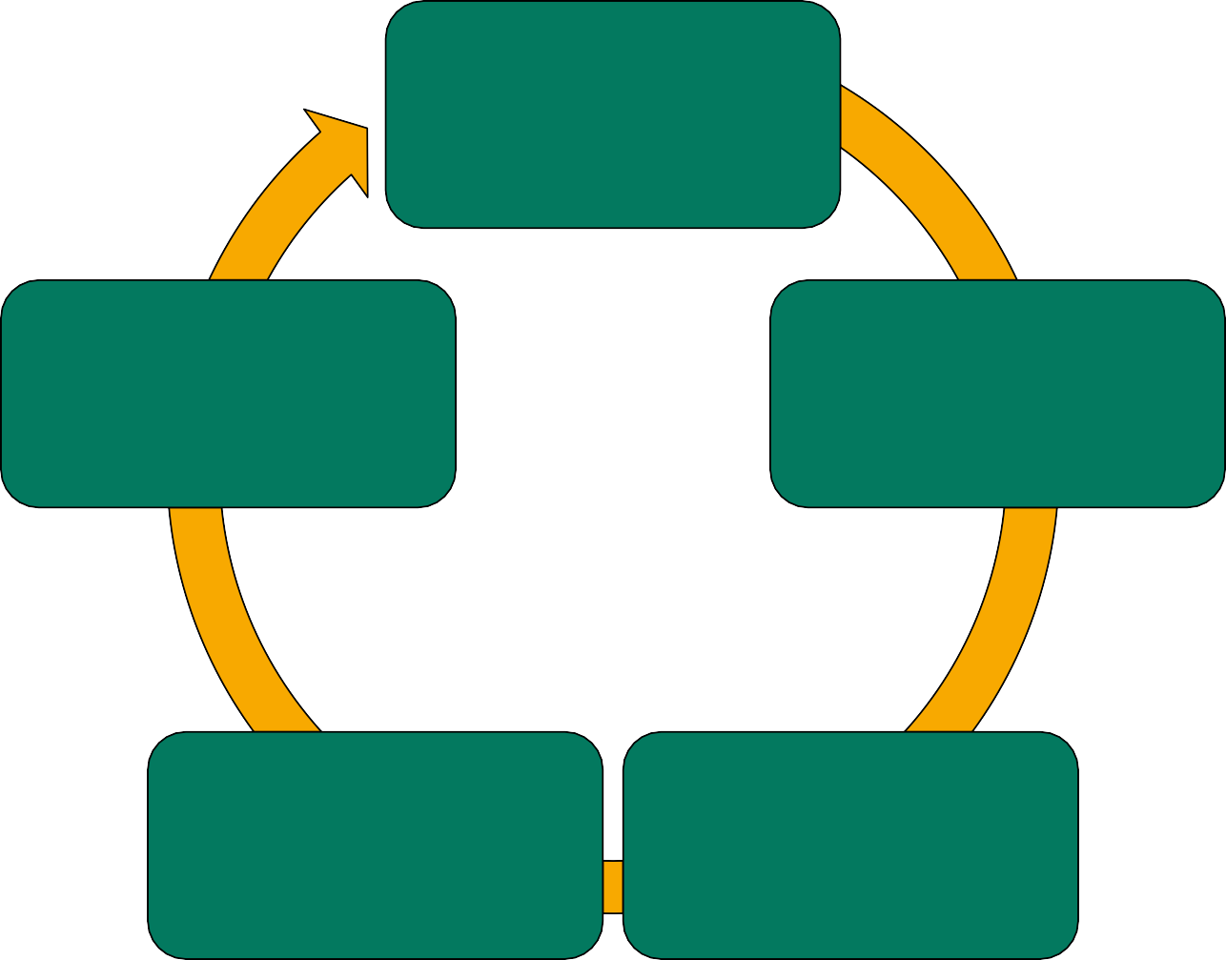
Submit Portfolios by February 1
Submit Dean’s Recommendations to Provost/VPAA by March 20
Complete Peer Evaluations by February 15
Submit Departmental Recommendations to Dean by March 10
Complete Department Chair’s Evaluations by February 20

